O-list Ecommerce – Requirements

### **BUSNIESS OVERVEW**

O-list store is one of the largest online departmental store headquartered in Sao Paulo, Brazil. This platform acts as a single point of contact for the local business owners to connect with their customers. The merchants are able to sell their products through O-List Store and then ship them to the customers using O-list logistics service partners. After a customer log-in to place an order, the nearby sellers are notified to fulfill that order. Once the customer receives the order, or estimated delivery date is due, or the order is returned etc., the customer gets a satisfaction survey email where he/she can give their review score or feedback for the purchase experience.



### **OBJECTIVE**

The main goal of this project is to conduct **Exploratory Data Analysis** on the real-time dataset mainly focusing on **improving customer reviews**. The problem statement can be further modified into analyzing customer satisfaction (positive or negative) for the purchases made on the site.

### **DATASET**

* The dataset provided has information of 100k orders from 2016 to 2018 made at multiple marketplaces in Brazil
* It consists of 9 different dataset
* Size of csv files is 106MB

The schema of the dataset is as below -

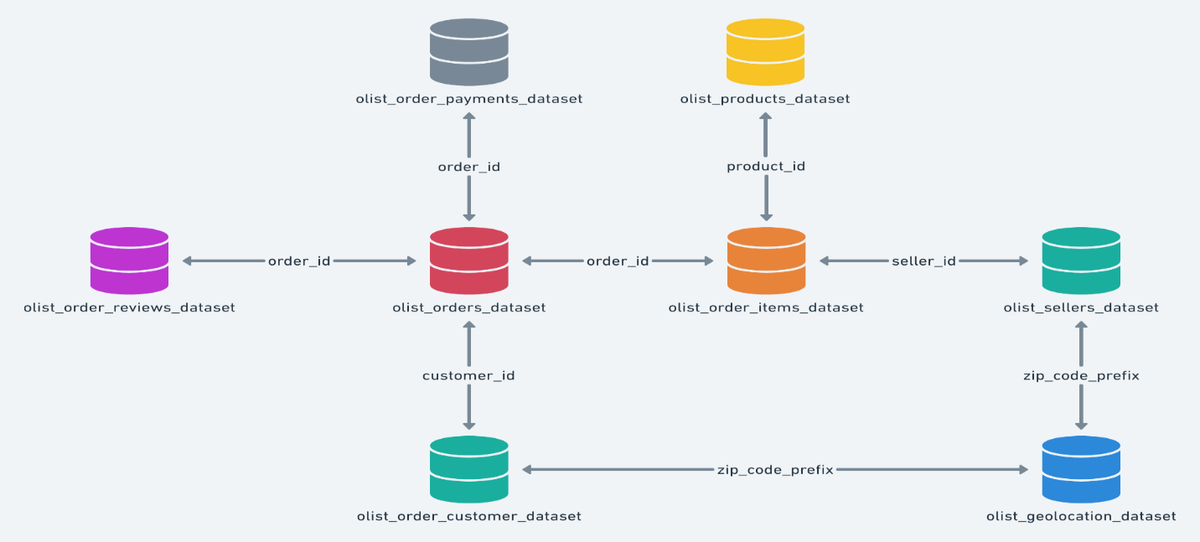

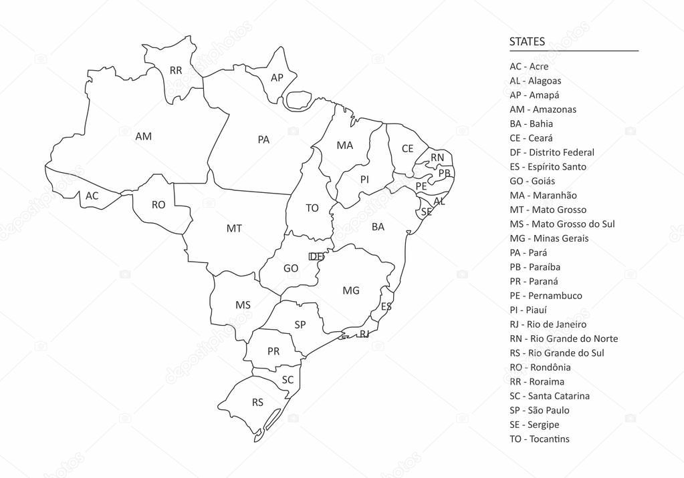

Following are the 9 datasets –

* olist_order_customers_dataset

This dataset has information about the customer and its location. Use it to identify unique customers in the orders dataset and to find the orders delivery location.

* olist_geolocation_dataset

This dataset has information Brazilian zip codes and its latitude/longitude coordinates.

* olist_order_items_dataset

This dataset includes data about the items purchased within each order.

* olist_order_payments_dataset

This dataset includes data about the payment options used by the customers.

* olist_order_reviews_dataset

This dataset includes data about the reviews made by the customers.

* olist_orders_dataset

This is the core dataset. Every necessary information is mapped to each order in this.

* olist_products_dataset

This dataset includes data about the products sold by O-List.

* olist_sellers_dataset

This dataset includes data about the sellers that fulfilled orders made at O-List.